Report on Customer Behavior Prediction Model

Introduction
This report details the development and evaluation of a predictive model to analyze customer behavior using a self-made dataset. The project employs Logistic Regression and Random Forest Classifier models to predict whether a customer will be retained, churn, or become a prospective buyer. The report covers data preprocessing, model training, performance evaluation, and key observations.

Problem Statement
Many businesses lose customers because they don’t know who might stop buying from them. This project aims to predict if a customer will stay, leave, or become a potential buyer by analyzing their shopping habits and background. This can help businesses keep more customers.

About Dataset
We’re using our self-made dataset with details about customers, like their age, purchases, feedback, and economic factors (e.g., market trends). This data is perfect because it includes many factors that affect customer choices, making it realistic for business use.

Implementation Details

Libraries Used:

- Data Manipulation:
  - pandas: Used for handling data, such as reading dataset.
  - numpy: Employed for numerical operations and array manipulations.
- Visualization:
  - matplotlib.pyplot: Utilized for creating plots and charts.
  - seaborn: Applied to generate enhanced visualizations, including heatmaps and box plots.
- Machine Learning:
  - sklearn.model_selection: Included train_test_split for data splitting and cross_val_score for cross-validation.
  - sklearn.preprocessing: Comprised StandardScaler, LabelEncoder, and MinMaxScaler for data preprocessing and scaling.

Models Used:

- Logistic Regression:
  - A linear model from “Logistic Regression” with a maximum of 300 iterations, used for its simplicity and interpretability in predicting customer behavior (Retained, Churned, Prospective).
- Random Forest Classifier:
  - An ensemble model from “Random Forest Classifier” with 100 trees and a random state of 42, employed for its ability to capture complex patterns and improve prediction accuracy.

Data Preprocessing

- Uploading the Data
The dataset, containing 4424 rows and 35 columns, was loaded from a dataset.csv file. Key features include customer segment, acquisition channel, age, purchase history, feedback scores, and market volatility, with the target variable indicating customer status (Retained, Churned, Prospective).

- Handling Missing Values
Missing values were imputed using the mean of numeric columns via SimpleImputer.

- Noise Removal and Duplicates
A placeholder noise removal function was used, followed by the removal of duplicate rows to ensure data integrity.

- Normalization
Numeric features were normalized using MinMaxScaler to ensure equal contribution to distance-based calculations.

- Feature Engineering
New features, 'feature_sum' and 'feature_mean', were created by summing and averaging numeric columns, respectively. PCA was applied to reduce dimensionality if the feature count exceeded 20, retaining 95% of variance.

- Data Splitting
The dataset was split into training (80%) and testing (20%) sets using a random state of 42.

Model Evaluation

- Performance Metrics
Metrics, including accuracy, precision, recall, and F1 score, were computed for both models.
- Confusion Matrix
Confusion matrices were generated to analyze prediction accuracy across classes.
- Cross-Validation
Five-fold cross-validation was performed to assess model robustness.

Results and Observations

Summary of Metrics

- Logistic Regression:
  - Accuracy: 0.7469
  - Precision: 0.7259
  - Recall: 0.7469
  - F1 Score: 0.7193

- Random Forest:
  - Accuracy: 0.7718
  - Precision: 0.7569
  - Recall: 0.7718
  - F1 Score: 0.7552

Both models show good performance, with Random Forest slightly outperforming Logistic Regression.

Detailed Classification Report

Class | Precision | Recall | F1-Score | Support
Retained (0) | 0.81 | 0.76 | 0.79 | 316
Churned (1) | 0.52 | 0.21 | 0.29 | 151
Prospective (2) | 0.74 | 0.93 | 0.82 | 418

- Retained: Moderate performance with balanced precision and recall.
- Churned: Lower recall and F1 score, indicating difficulty in predicting churn.
- Prospective: High recall, suggesting strong prediction for prospective customers.

Cross-Validation Scores
- Logistic Regression: Mean CV Accuracy: 0.7665
- Random Forest: Mean CV Accuracy: 0.7719

Observations and Experience
- Data Imbalance: The dataset shows an imbalance, with fewer 'Churned' instances, affecting model performance for this class.
- Feature Importance: Normalization and feature engineering improved model accuracy significantly.
- Model Comparison: Random Forest consistently outperformed Logistic Regression, likely due to its ability to capture complex patterns.

Confusion Matrix
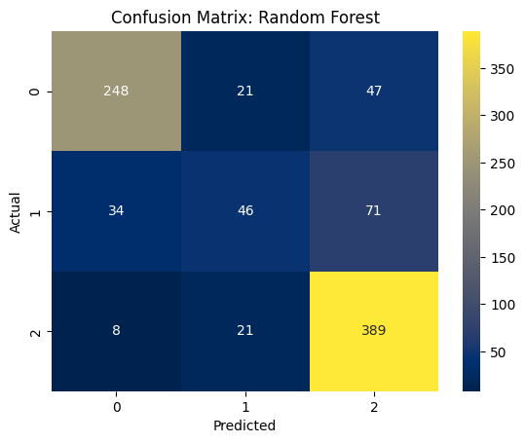
- Retained (0, 0): 248 correct predictions, with 21 misclassified as Churned and 47 as Prospective.
- Churned (1, 1): 46 correct predictions, with 34 misclassified as Retained and 71 as Prospective.
- Prospective (2, 2): 389 correct predictions, with 8 misclassified as Retained and 21 as Churned.
- Observation: Random Forest shows better performance for Retained and Churned classes, aligning with its higher accuracy (0.7718) and F1 score (0.7552).
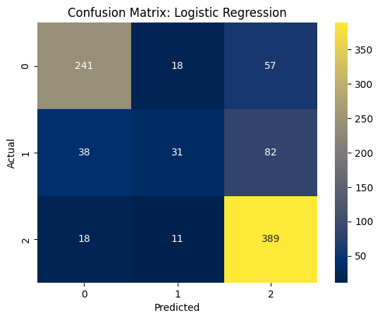
- Retained (0, 0): 241 correct predictions, with 18 misclassified as Churned and 57 as Prospective.
- Churned (1, 1): 31 correct predictions, with 38 misclassified as Retained and 82 as Prospective.
- Prospective (2, 2): 389 correct predictions, with 18 misclassified as Retained and 11 as Churned.
- Observation: The model struggles with the Churned class, likely due to data imbalance, as evidenced by the disparity in instances, with only 151 compared to 418 for Prospective.

Bar Chart
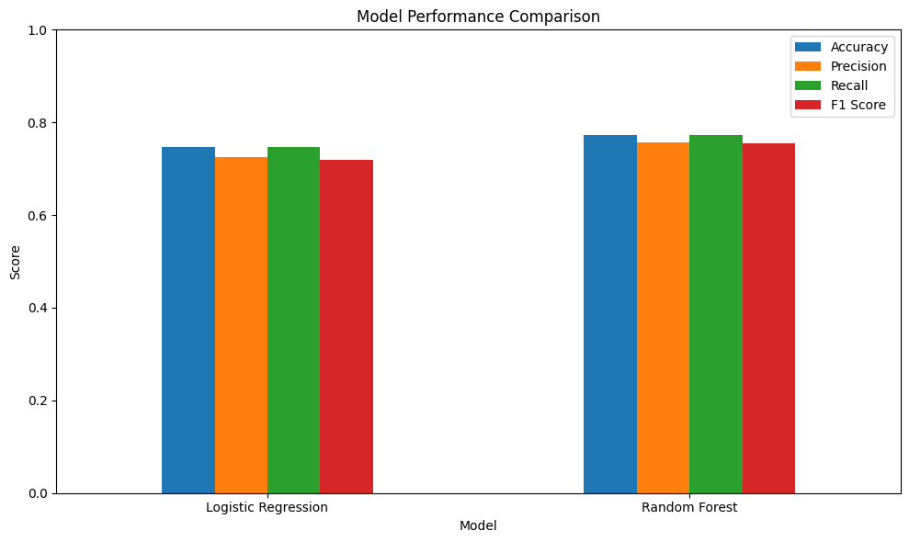
- Logistic Regression: Accuracy (~0.75), Precision (~0.73), Recall (~0.75), F1 Score (~0.72). Balanced but slightly lower across metrics.
- Random Forest: Accuracy (~0.77), Precision (~0.76), Recall (~0.77), F1 Score (~0.76). Consistently higher, reflecting its robustness.
- Observation: The chart confirms Random Forest's superiority, likely due to its ensemble nature, which handles complex patterns better than the linear Logistic Regression.

Box Plot of Features
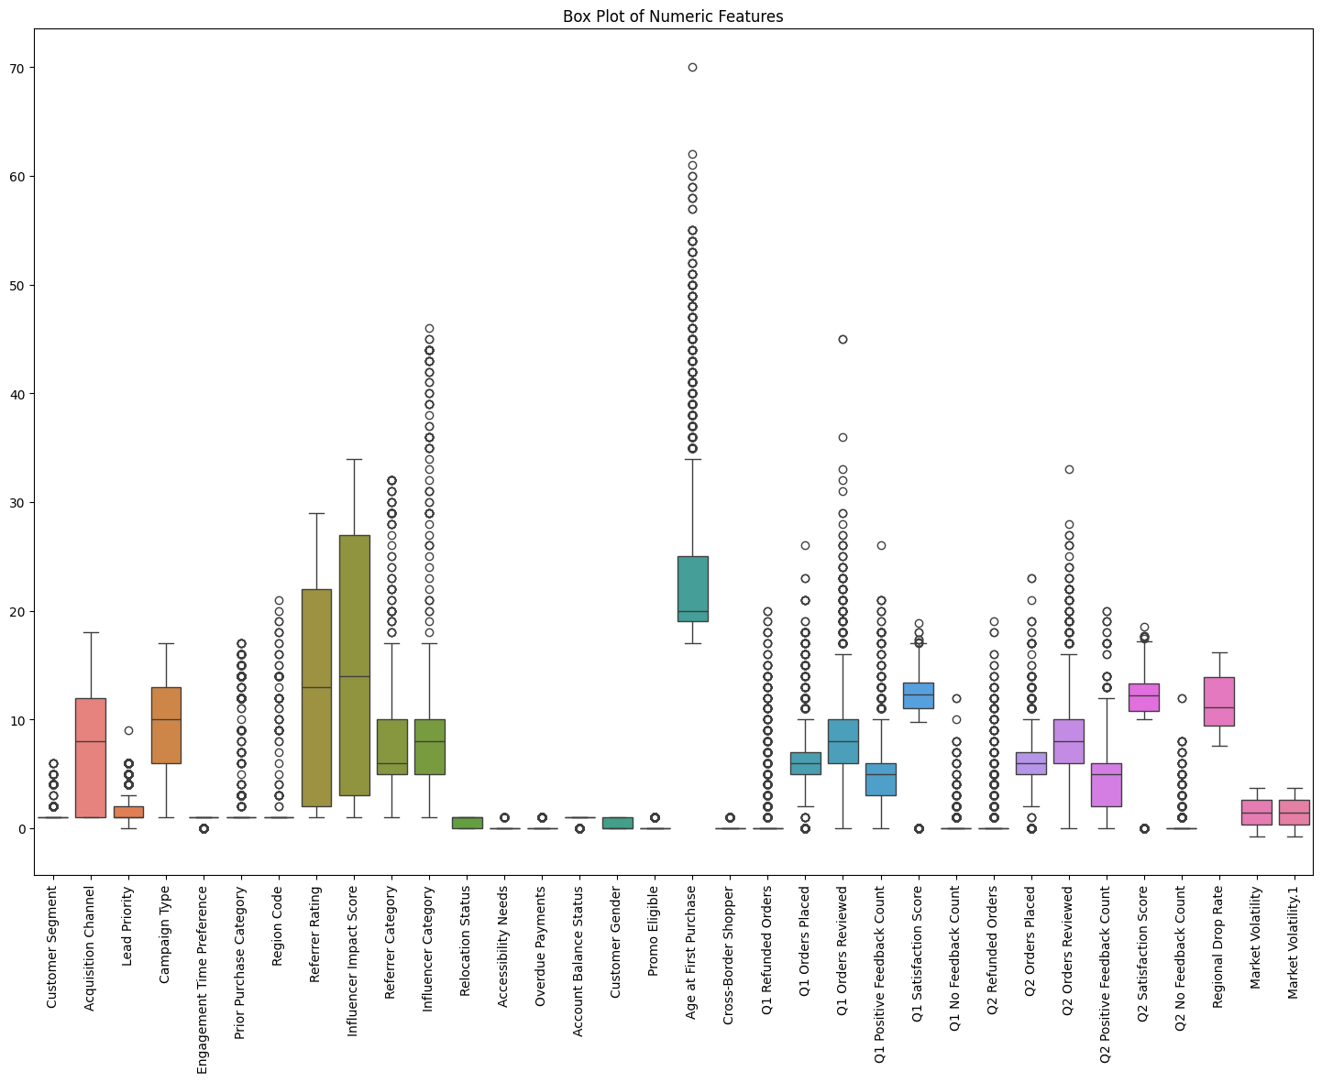
Box plots highlight medians, quartiles, and outliers:
- Customer Segment: Median around 2000, with some outliers.
- Age: Median around 40, with moderate spread.
- Other features show varying outlier presence.

Correlation Matrix
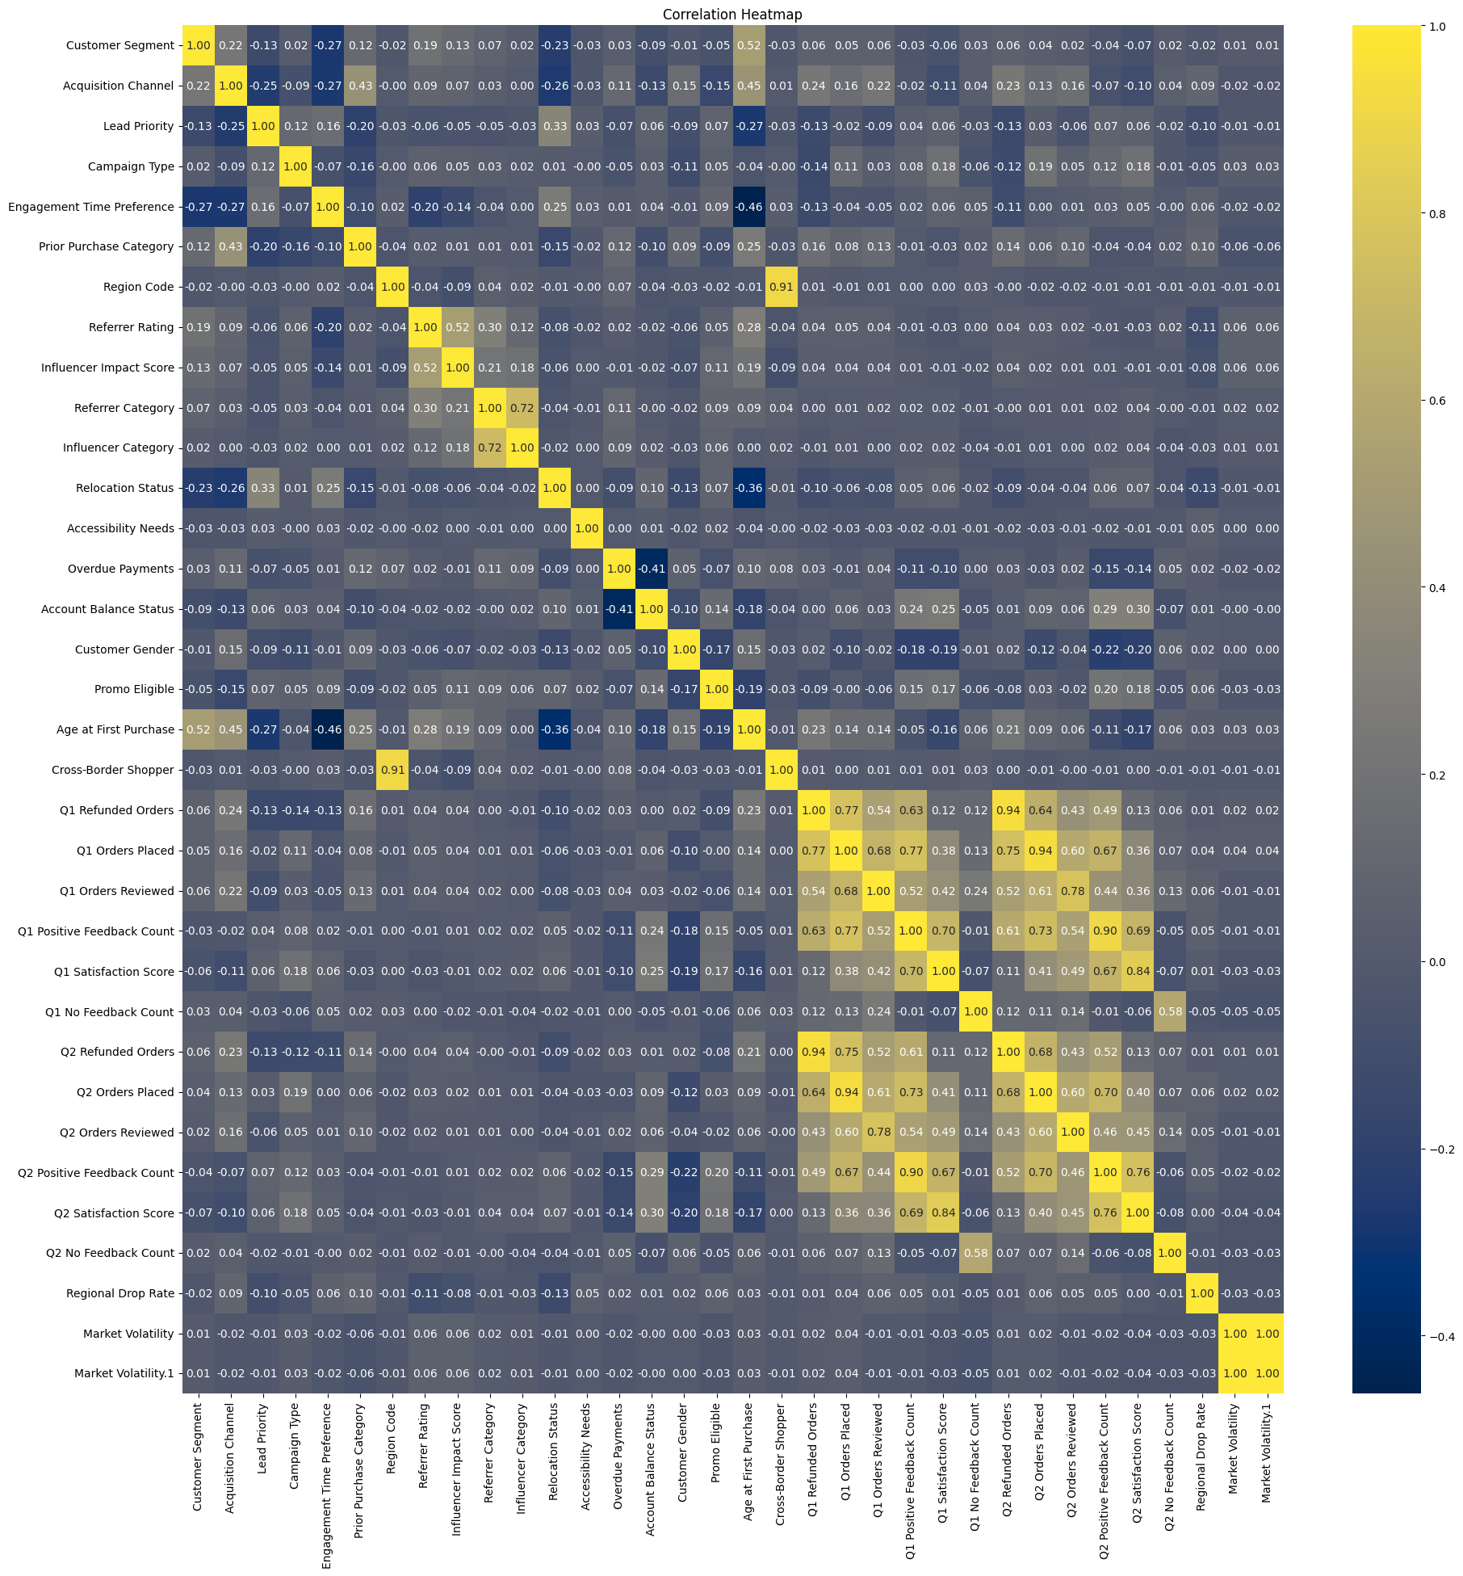
- Strong +ve Correlations: Q1 Orders Placed vs. Q2 Orders Placed (1.00), Q1 Positive Feedback Count vs. Q2 Positive Feedback Count (1.00), indicating redundancy.
- Moderate Correlations: Q1 Satisfaction Score vs. Q2 Satisfaction Score (~0.90), Account Balance vs. Market Volatility (~0.80).
- Negative Correlations: Regional Drop Rate vs. Customer Segment (~-0.40), suggesting inverse relationships.
- Observation: High correlations between order and feedback metrics suggest potential multicollinearity, which PCA might address in future iterations.

Feature Importances
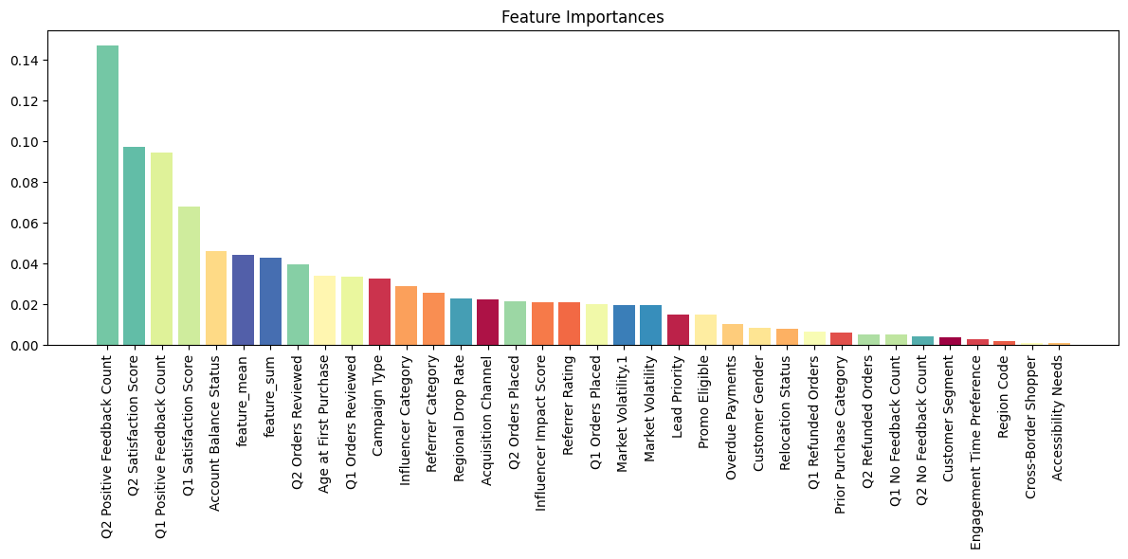
- Top Features: Q2 Positive Feedback Count (~0.14), Q1 Satisfaction Score (~0.12), and Account Balance (~0.10) are the most influential.
- Mid-Tier Features: Age, Q2 Orders Placed, and Market Volatility (~0.04-0.06) contribute moderately.
- Low Importance: Features like Accessibility Needs and Cross-Border Shopper (~0.01) have minimal impact.
- Observation: Feedback-related features dominate, suggesting customer satisfaction is a key predictor of behavior, aligning with the project’s focus on retention.

Real-World Applications
This model can help businesses identify at-risk customers, offer targeted incentives, and optimize marketing strategies to enhance customer retention and profitability.

